**NAME: ALI GHULAM MURTAZA**

**ROLL NO: SFI-24S-001**

LAB NO: 4

**TASK NO 1: Write a Python program to take two numbers as input and perform all arithmetic operations on them.**

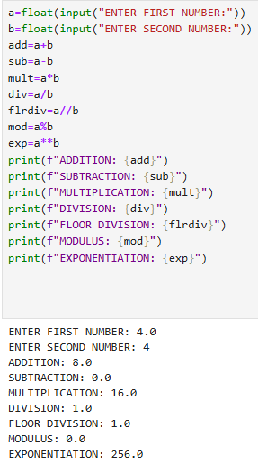

**TASK NO 2: Create a function that takes two numbers and returns their sum, difference, product, and quotient.**

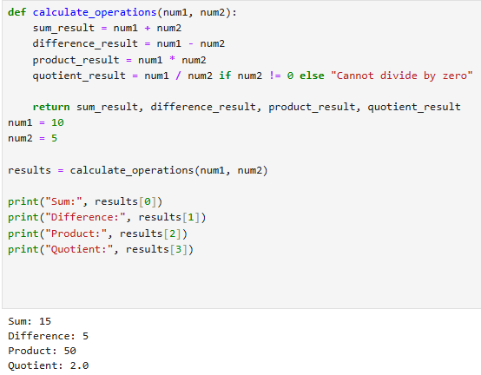

**TASK NO 3: Write a Python script to find the remainder when one number is divided by another.**

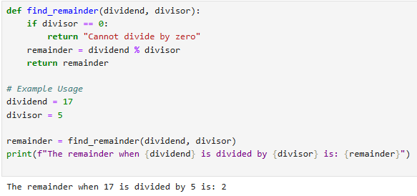

**TASK NO 4: Write a program to calculate the area of a circle using the formula: Area = π * r^2.**

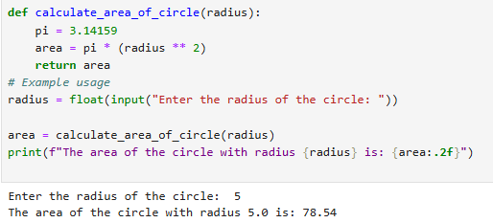

**TASK NO 5: Implement a program that takes a number as input and returns its square and cube using exponentiation.**

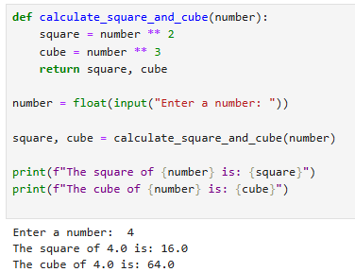

**TASK NO 6: Create a simple calculator in Python that allows the user to choose an operation (addition, subtraction, etc.) and inputs two numbers.**

